Snowball:

Before snowball there was a legacy service.

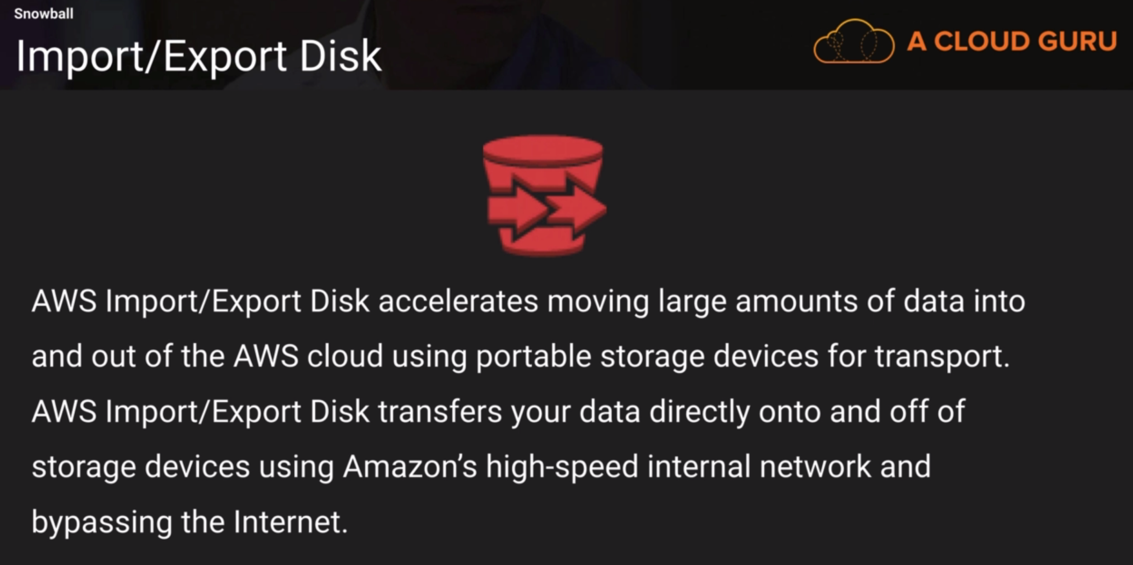

If you had a slow network and wanted to transfer lot of data to s3, you send disks to amazon who will import them to s3 bypassing the internet. But everybody started sending all kinds of devices.

So, amazon created snowball. It can import to and export data from s3.

There are 3 types:

* Snowball
* Snowball edge
* Snowmobile

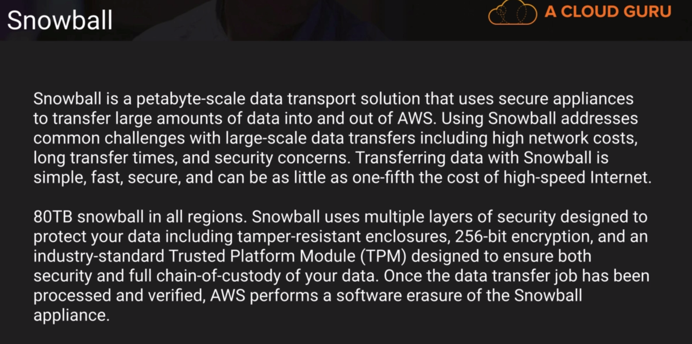

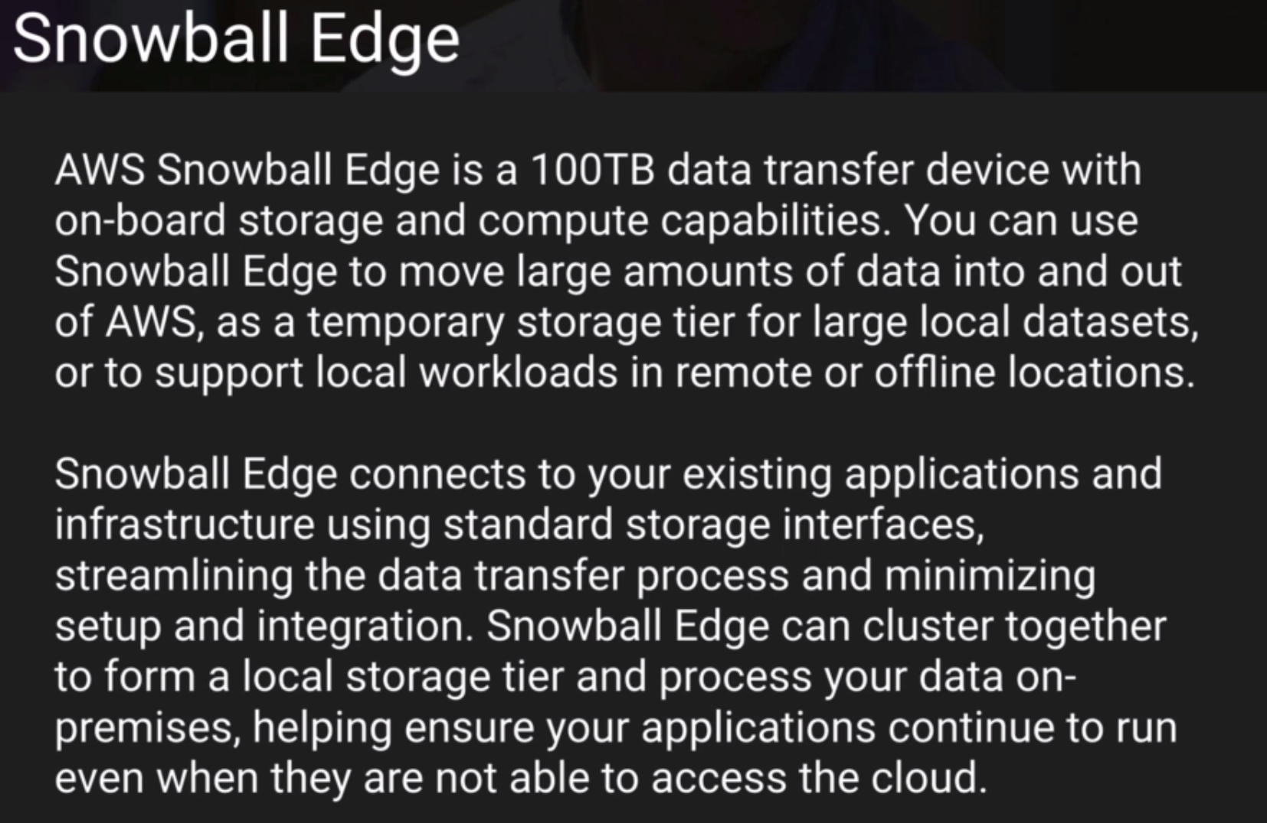

Snowball edge brings compute capacity in addition to storage. It can be plugged to an airplane in flight and a lambda expression can compute and collect data. Then that data can be exported to s3 for analysis.

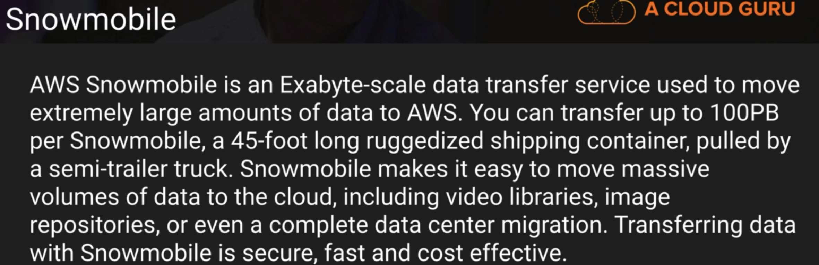

It can move data in 6 months, which would have taken 25 years through internet.

To move data from glacier, it has to be first restored to s3 and then put in a snowball.

To use snowball, we need to download client, connect snowball and run command like below.



To start snowball we will need the ip address displayed in snowball, the manifest file and the access code from aws console snowball job.

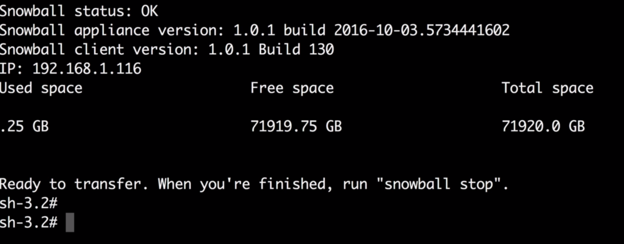

Copy file to be transferred to snowball. The s3 bucket is the one mentioned in the snowball job.

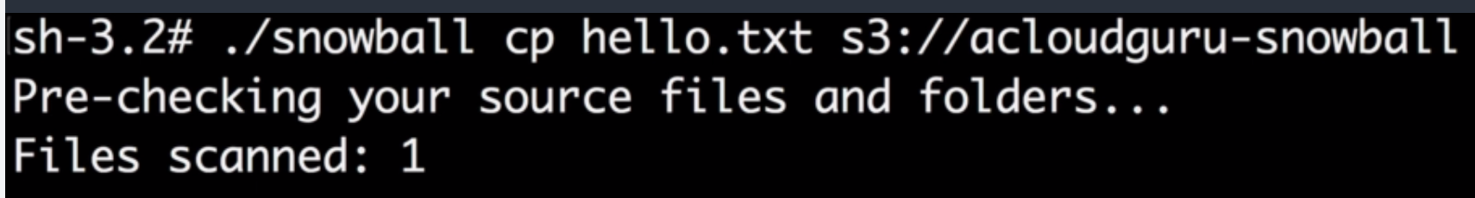

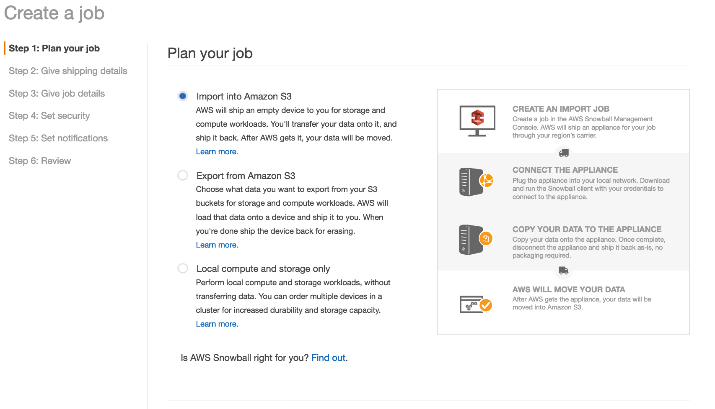

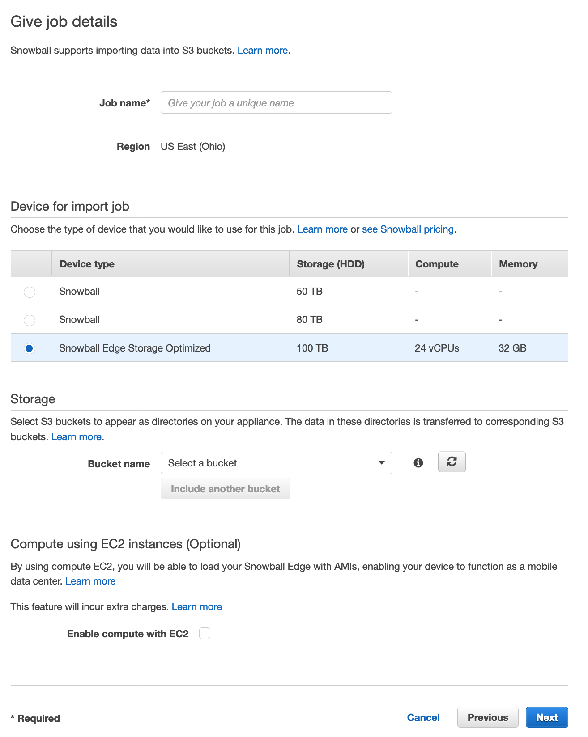

**Transfer Acceleration:**

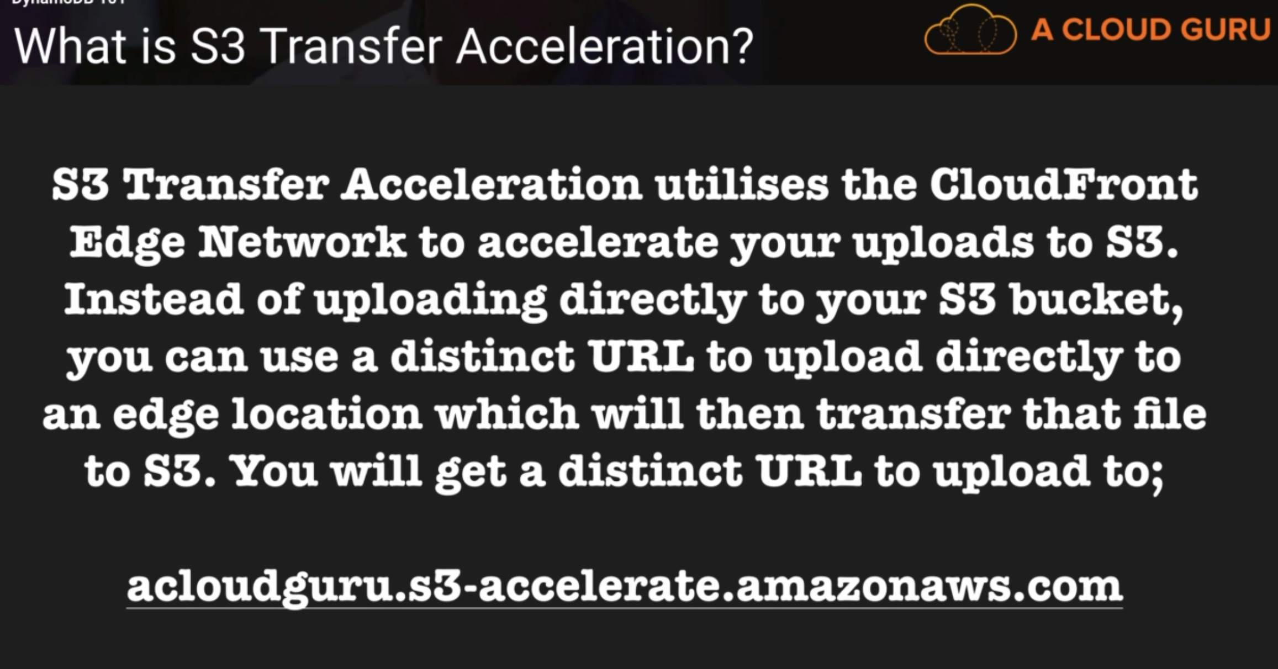

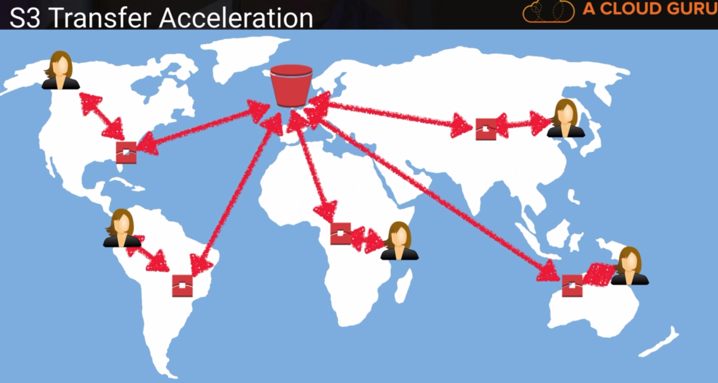

Bucket Properties > Advanced Settings:

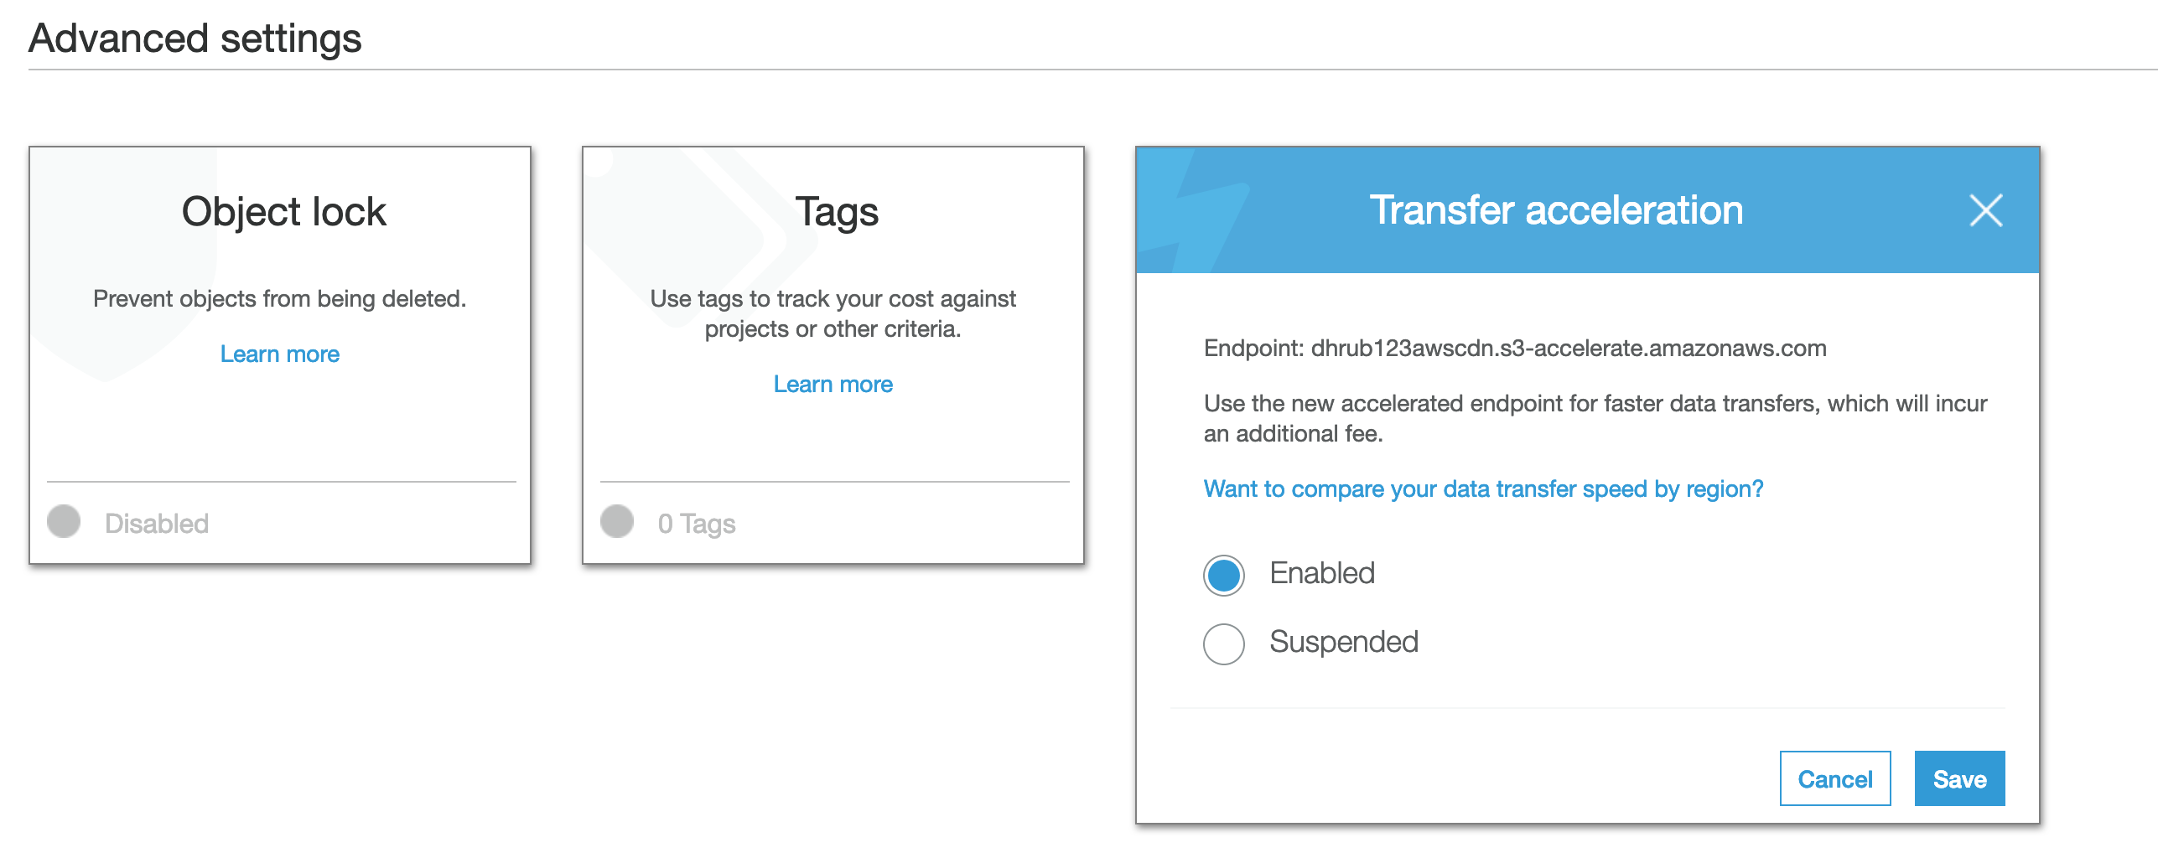

The endpoint is different. It uses a sub domain of s3 called s3-accelerate and uses CloudFront underlying. To compare speeds, click on compare speeds link.

**S3 static website hosting:**

* Bucket policies can be used to make entire buckets public.
* S3 website hosting can only be used for STATIC hosting. Dynamic websites requiring DB connections cannot be hosted in S3.
* It scales automatically to meet demand. A good example can be a movie preview where a large number of requests come to view a static website.

Bucket Properties > Static Website Hosting

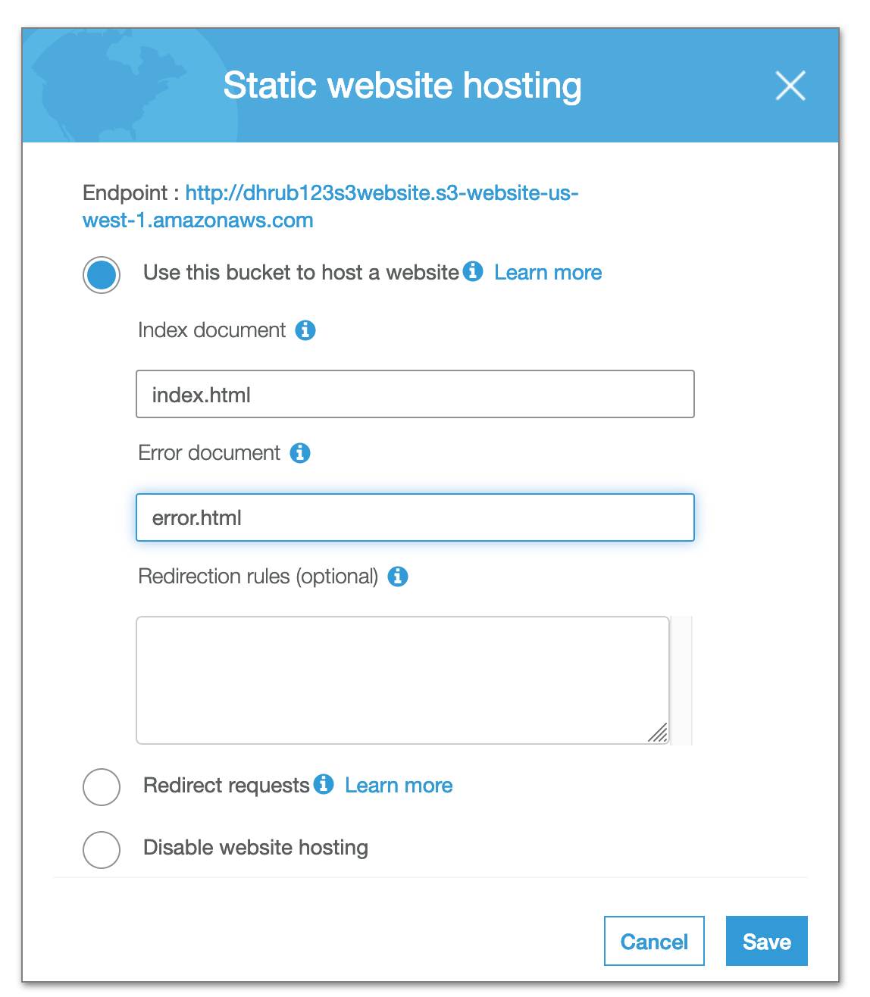

Format of endpoint:

<http://dhrub123s3website.s3-website-us-west-1.amazonaws.com>

<http://bucketname.s3-website-region.amazonaws.com>

We can define the index and error document.

We need to make the bucket and all its contents public.

The bucket policy is changed to make it publicly accessible.

A bucket policy is added to make individual files public.

{

"Version":"2012-10-17",

"Statement":[{

"Sid":"PublicReadGetObject",

"Effect":"Allow",

"Principal": "*",

"Action":["s3:GetObject"],

"Resource":["arn:aws:s3:::dhrub123s3website/*"

]

}

]

}





When we hit <http://dhrub123s3website.s3-website-us-west-1.amazonaws.com/> , we are displayed index.html. When we hit an invalid URL like <http://dhrub123s3website.s3-website-us-west-1.amazonaws.com/e> , we are displayed the error page.

**AWS Storage gateway:**

It is a service that connects an organization’s on premise software appliance with cloud based storage to provide seamless integration between the organization’s on premise IT environment and AWS storage infrastructure. It enables secure, scalable and cost effective data storage in cloud.

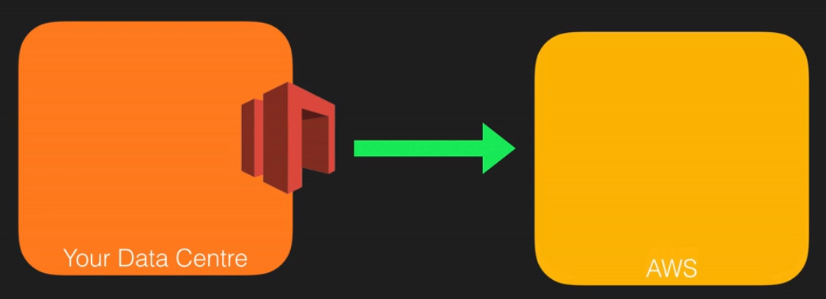

The storage gateway is a virtual appliance installed in a hypervisor running in a datacenter which propagates or asynchronously replicates information to AWS s3 or glacier.

AWS Storage Gateway is a software appliance which can be downloaded as a virtual machine image and then installed on a host in datacenter. It supports VMware ESXi or Microsoft Hyer-V. Once installed and associated with AWS account through activation, AWS management console can be used to choose the correct storage gateway option.

Four types of storage gateways:

* File gateway (NFS) – File storage(PDFs etc.)
* Volumes gateway (iSCSI) – block based storage for VMs or SQL server etc.
  + Stored Volumes
  + Cached Volumes – Most accessed data
* Tape gateway (VTL) – backup and archive

**File gateway:**

Files are stored as objects in S3 buckets, accessed through a network File System (NFS) mount point. Ownership, permissions and timestamps are durably stored in S3 in user-metadata of the object associated with the file. Once objects are transferred to S3, they can be managed as native s3 objects and bucket policies such as versioning, lifecycle management and cross region replication apply directly to them.

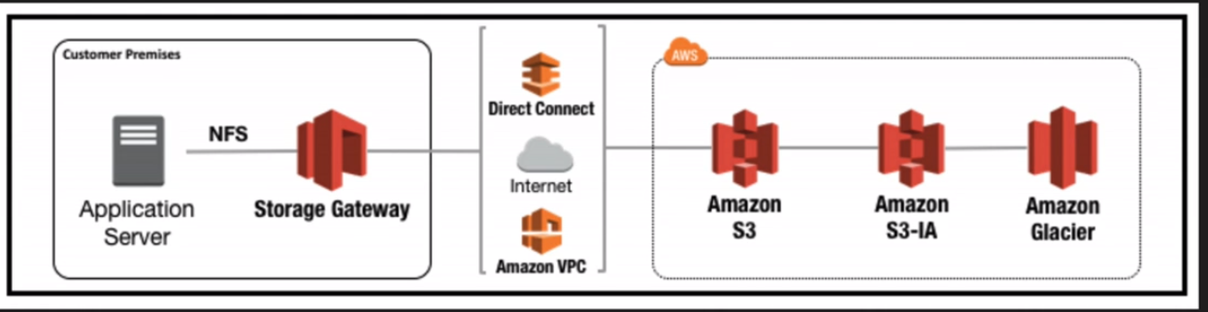

**Volume Gateway (virtual hard disks):**

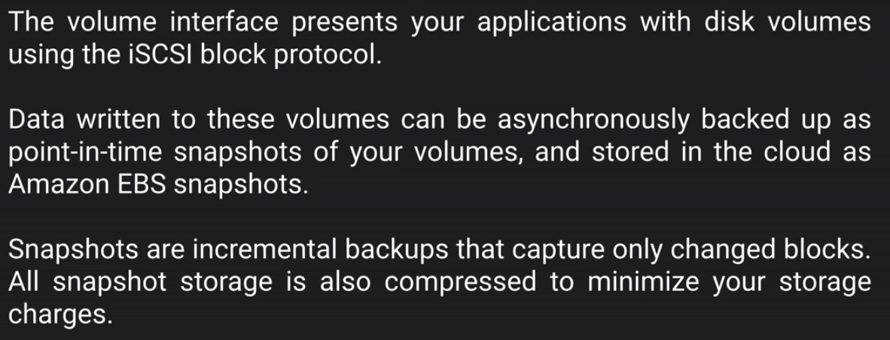

1. **Stored Volumes:**

Here the key thing is the entire data is present in on premise as well as backed up in AWS. So this is suitable for scenarios where an on premise application needs quick access to entire data.

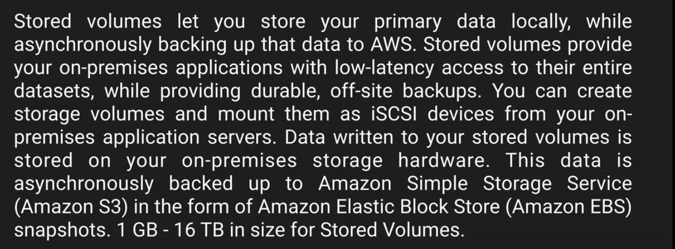

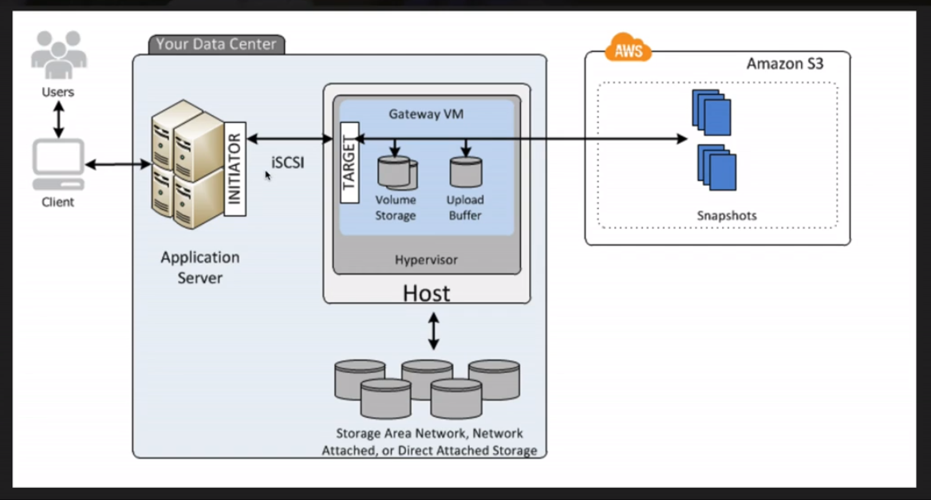

1. **Cached Volumes:**

Here the key thing is only recent data is present in on premise and rest are backed up in AWS. So this is suitable for scenarios where quick access to most recent data is sufficient.

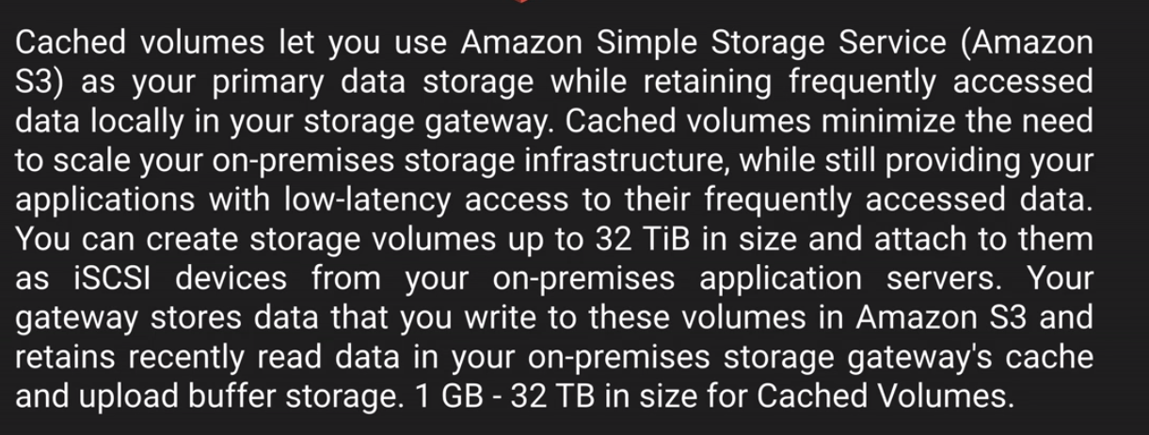

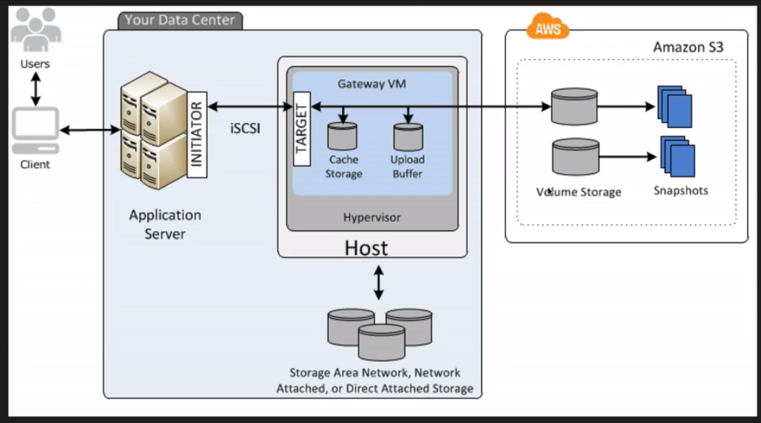

**Tape Gateway:**

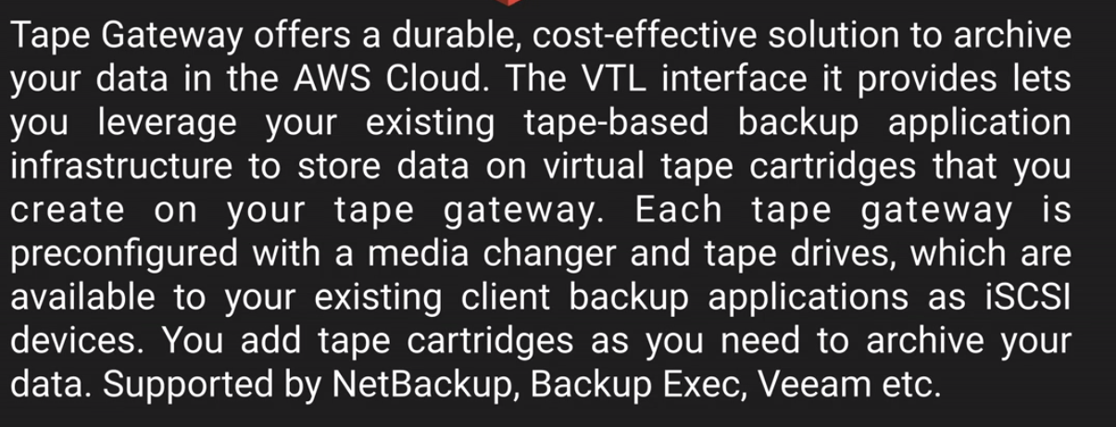

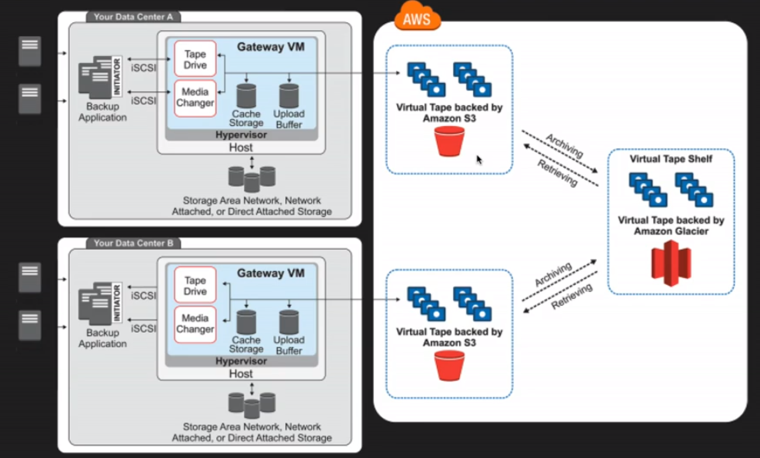

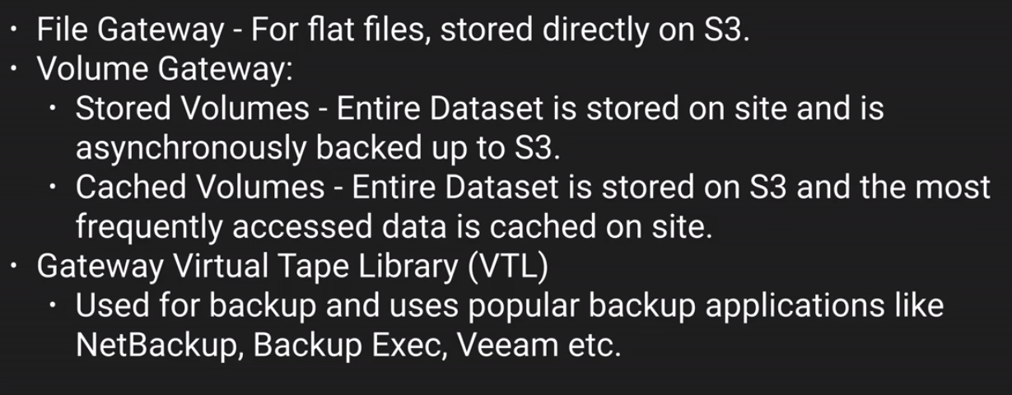

**Exam Tips:**

* S3 is object based, it allows us to upload files.
* File size ranges from 0 bytes to 5TB.
* Storage is unlimited.
* Files are stored in buckets.
* Load files much faster using multipart upload
* S3 is universal namespace, names must be unique globally.
* <https://s3-eu-west-1.amazonaws.com/acloudguru>
* Read after write consistency for PUTS of new objects
* Eventual Consistency for overwrite PUTS and DELETES(can take time to propagate)
* Core fundamentals – Key(name), Value(Data), Version ID, Metadata, Access Control Lists
* Object based storage only for files, not suitable for OS or database
* Lifecycle Management
  + Can be used with versioning
  + Can be applied to current and previous versions
  + Transition to standard IA(128 Kb and 30 days after creation date)
  + Archive to Glacier(30 days after IA, if relevant) or immediately after creation
  + Permanently delete object
* Versioning
  + Stores all versions of an object(including all writes and even if you delete object)
  + Great backup tool
  + Once enabled, versioning can only be suspended.
  + Integrates with lifecycle management
  + MFA delete capability
  + CRR requires versioning enabled on source and destination bucket.
  + You have to pay for all versions. If a 1 gig object has 2 versions, we pay for 2 gigs.

Storage Tiers:

